**NYC Volunteer Management System User Manual**

**1. System Overview**

The NYC Volunteer Management System is designed for NYC club volunteer management and includes six function modules: Member Management, Team Member Management, Admin Management, Volunteer Points, Events, and Reports. This manual will provide detailed guidance on how to use each section.

**2. Logging into the System**

* 1. Open your web browser and go to the system's URL: http://localhost:3000/.
  2. On the login page, enter your username and password.
  3. Click the “**Login”** button to enter the main interface of the system.

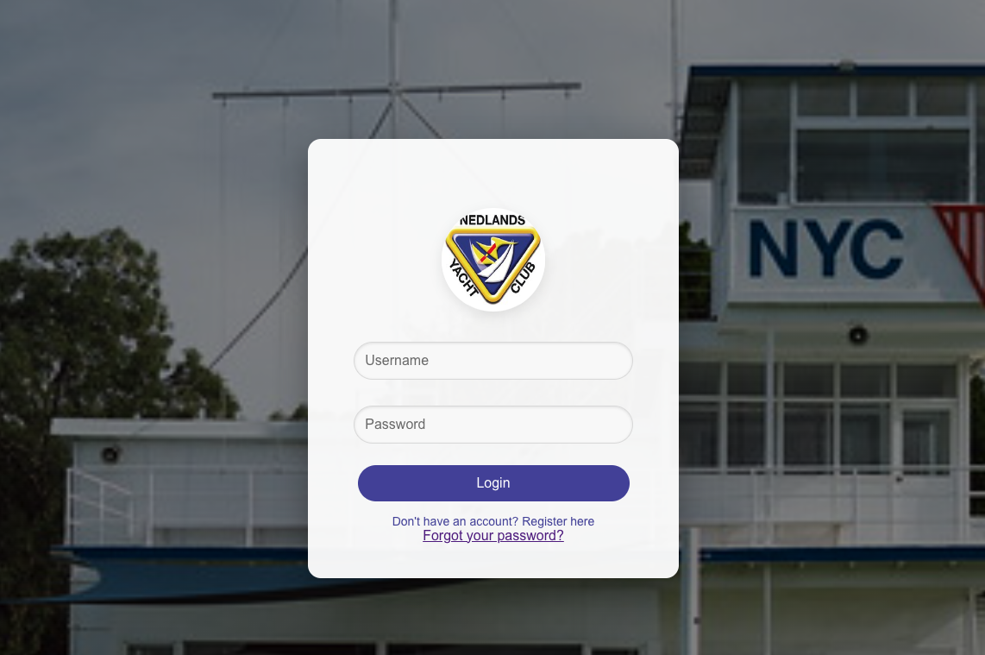

**3. Main Interface**

The main interface of the system includes 9 sections: Home, Member Management, Team Member Management, Admin Management, Volunteer Points, Events, Reports, Change Password, and Logout. Each section will be detailed below.

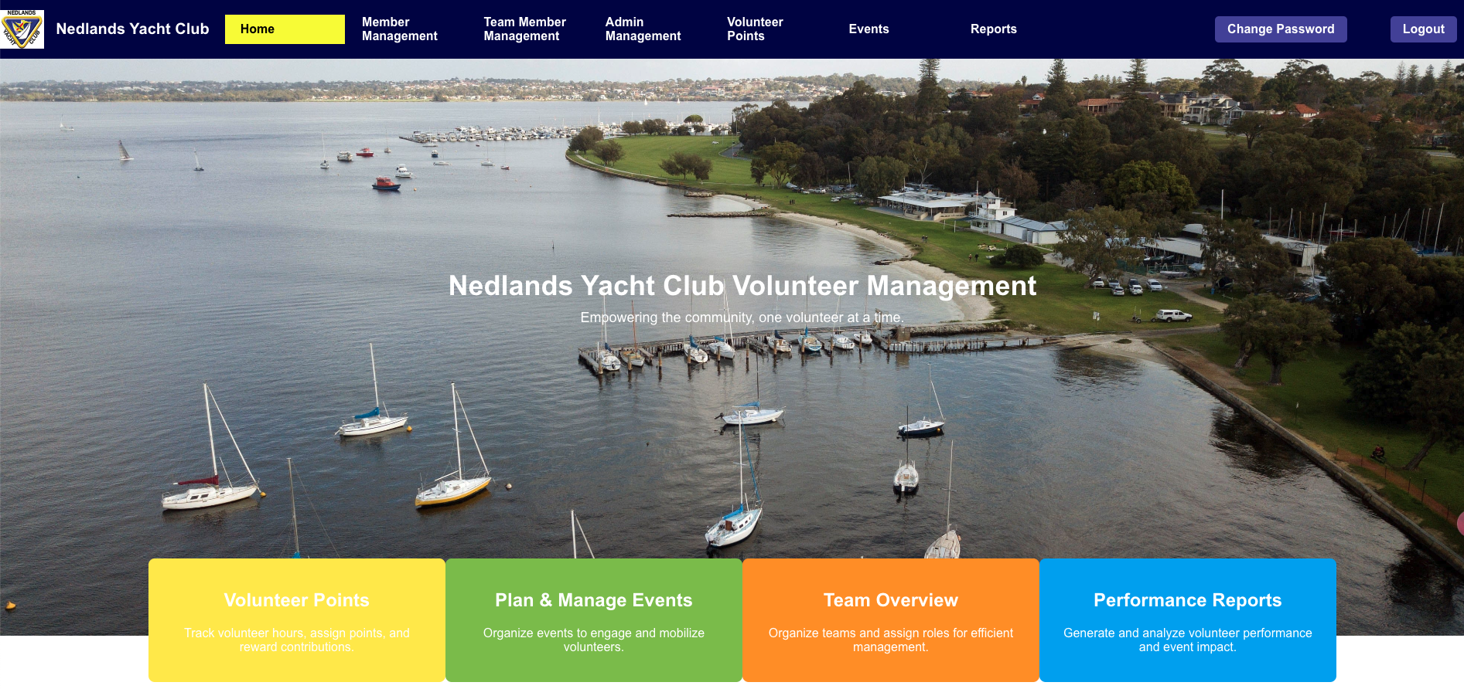

**3.1. Member Management**

The Member Management page primarily facilitates the import and export of member information via specific CSV files and allows for viewing member details.

**3.1.1 Viewing the Member List:**

* Click on “**Member Management”** to view a detailed list of all members, including their ID, name, email, phone number, member category, volunteer status, and team affiliation.

* + 1. **Selection and Operations:**
       1. Select All: Click “Select All” to select all members on the current page.
       2. Select Inverse: Click “Select Inverse” to reverse the current selection.
       3. Unselect All: Click “Unselect All” to deselect all members on the current page.
       4. Export Data: Click “Export Selected to CSV” to export the selected member information to a CSV file.
       5. Import Member Data: Click “Import from CSV” to import member data from a CSV file into the system.
       6. All Data: Click “Export All to CSV” to export all member to a CSV file.

**3.2 Team Member Management**

Team Member Management is a feature designed for managing teams. Through this interface, admin users and team leaders can view detailed information about each team, edit team information, and add or remove team members.

**3.2.1 Entering the Team Member Management Page**

To access the team management page, click on "Team Member Management" in the system's main navigation bar.

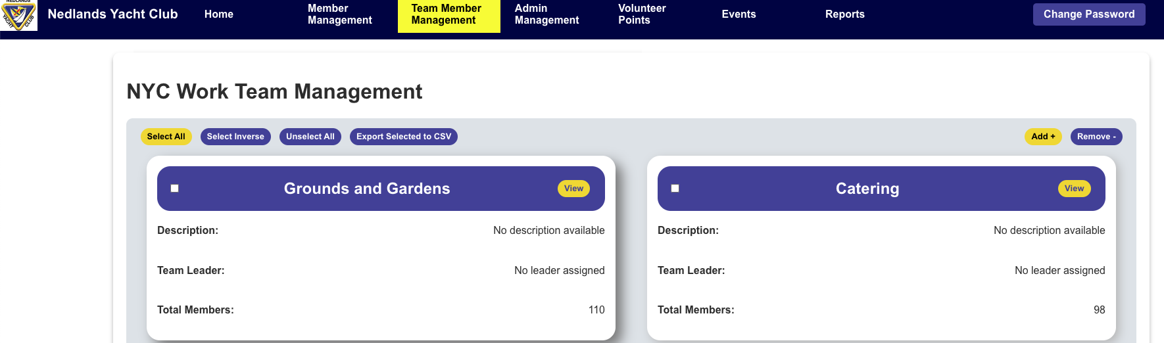

**3.2.2 Viewing the Team List**

Upon loading the page, you will see a list of all teams.

Each team card displays the team name, description, team leader, and the total number of team members.

To view more detailed information about a team, click the "View" button on the card.

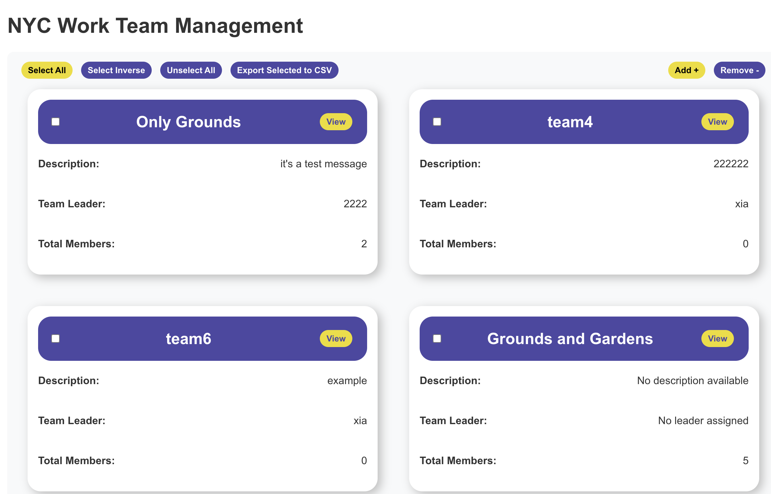

***View team member information***

**3.2.3 Selecting Options**

3.2.3.1 Select All: Click "Select All" to select all teams displayed on the page.

3.2.3.2 Select Inverse: Click "Select Inverse" to reverse the current selection.

3.2.3.3Unselect All: Click "Unselect All" to cancel all current selections.

3.2.3.4 Export Data: To export information about the selected teams, click "Export Selected to CSV".

**3.2.4 Adding and Removing Teams**

3.2.4.1 Create a New Team: Click "Add+" to create a new team.

3.2.4.2 Remove a Team: Select a team, then click "Remove-" to delete the selected team.

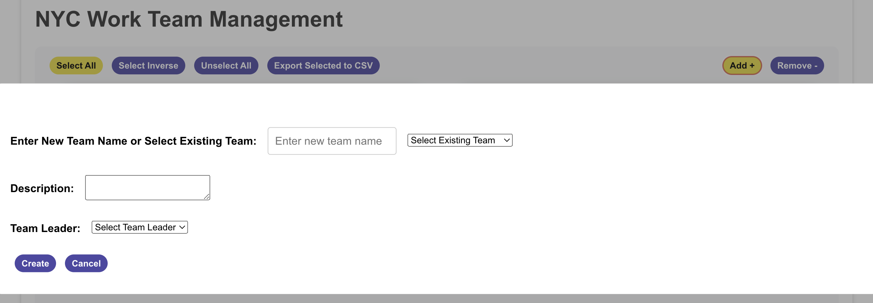

**3.2.5 Team Details**

Clicking the "View" button next to a team name will open a new window displaying detailed information about that team.

**3.2.6 Window Layout**

3.2.6 .1 Team Description: Displays a specific description of the team.

3.2.6 .2 Team Leader: Shows the currently assigned team leader.

3.2.6 .3 Team Members: Lists detailed information about all team members, including Member ID, name, email, phone number, membership type etc.

***Team information***

**3.2.7 Managing Team Members**

3.2.7.1 Add Member: Click the "Add Team Member" button to add members by entering their names; the input is case-insensitive.

3.2.7.2 Delete Members: After selecting one or more team members, click "Delete Team Member" to remove them.

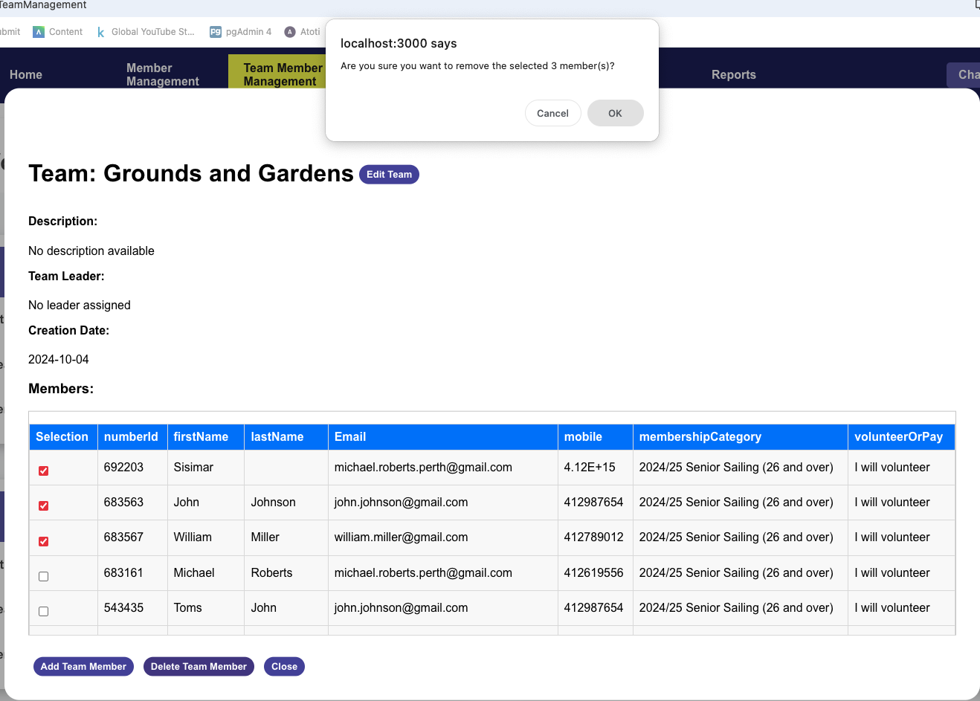

**3.2.8 Editing Team Information**

In the team details window, click the "Edit Team" button to edit the team.

After modifying the team's description or leader information, click save to update the data.

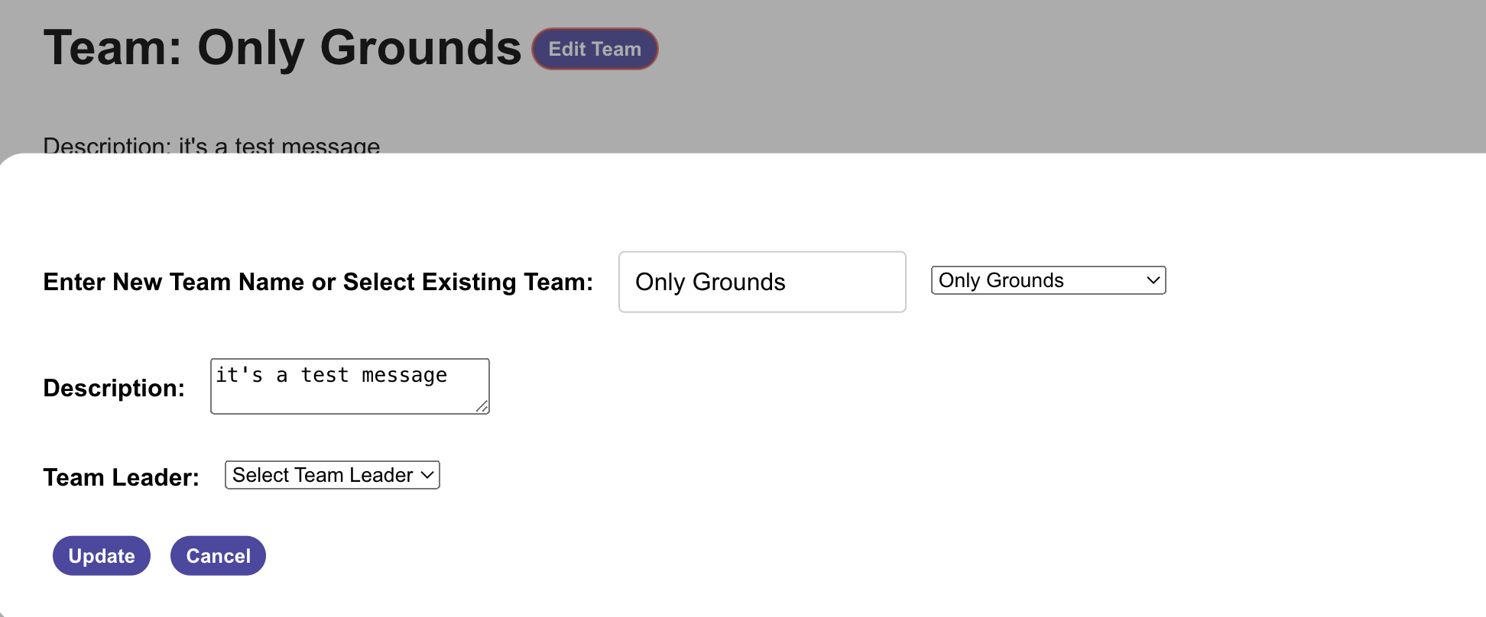

**3.2.9 Closing the Team Details Window**

After completing the review or modification of team information, click the "Close" button at the bottom of the window to return to the team list.

**3.3 Admin Management**

Admin Management is a feature specifically designed for administrative users, used to manage administrator and team leader accounts. This interface allows admin users to edit their profiles and create new admin or team leader accounts.

**3.3.1 Accessing the Admin Management Page**

Only users with administrative privileges can access this page. After logging into the system, click on "Admin Management" in the main navigation bar to enter the admin management interface. The Admin Management interface is divided into several key sections:

1. **Current User Information:** Displays the admin's username, current time information.
2. **Weather and Events Information:** Shows the current weather and a section for upcoming events.
3. **Search Functionality**: Provides a search bar to find current users by name, and to delete the user.
4. **Profile Editing:** Allows the admin to edit their profile details such as username, email.
5. **Account Creation:** Enables the creation of new admin or team leader accounts.
6. **Admin and Team Leader List:** This section provides a quick overview of all administrators and team leaders. It allows admin users to quickly see who else has administrative privileges.

Part61

Part3

Part1

Part41

Part51

Part2

**3.3.2 Managing Existing Users**

This area of the Admin Management interface allows for searching, viewing, and deleting existing admin and team leader accounts.

1. Search for a user: Enter the username or part of the username in the "Find the Current User" search bar and submit the query. This will retrieve and display the user's details.
2. Review user details: Once a user is found, their details such as username, email, and role will be displayed under the search bar.
3. Delete a user: If you need to remove an admin or team leader from the system, you can do so by clicking the "Delete" button next to their details. Confirm the deletion in the prompted confirmation dialog to permanently remove the user's account.

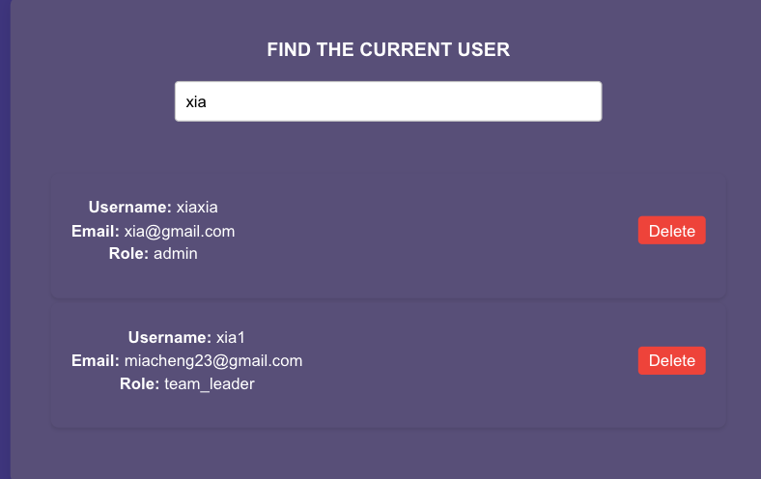

**3.3.3 Editing Personal Profile**In the "Edit Your Personal Profile" area, you can update your username, email address, and upload a new avatar.

1. Enter your new username in the "Username" field (if you wish to change it).
2. Update your email address in the "Email" field.
3. Click "Choose file" to upload a new avatar image(optional).
4. After completing the updates, click "Update Profile" to save the changes.

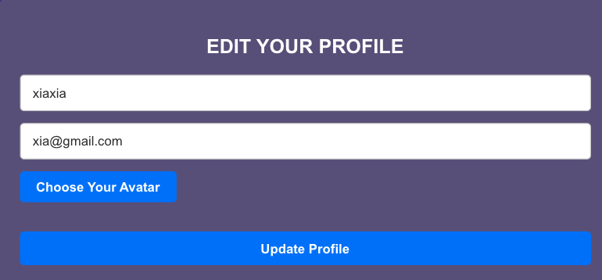

**3.3.4 Creating an Admin or Team Leader**

This area allows you to create new admin accounts or team leader accounts.

1. Enter the new admin's username in the "Username" field.
2. Set the new admin's password in the "Password" field.
3. Enter the new admin's email address in the "Email" field.
4. Click "Create Admin User / Create Team Leader" to create the new account.

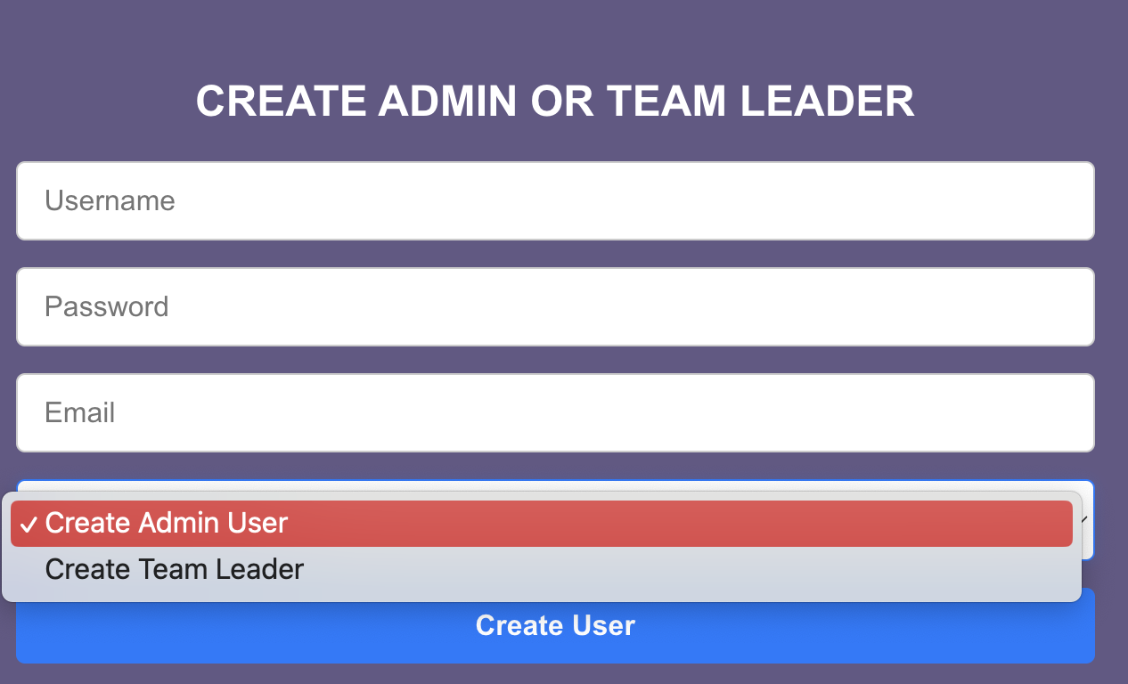

**3.3.5 Viewing the Admin and Team Leader List**

This section provides a quick overview of all administrators and team leaders. It allows admin users to quickly see who else has administrative privileges.

Total Admins and Team Leaders: The interface prominently displays the count of total admins and team leaders at the bottom of the sidebar, giving a quick numeric overview of the leadership structure.

Admin List Popup: Clicking on the count of total admins or team leaders will trigger a popup that lists the usernames and associated email addresses of all admins and team leaders.

a) Access the List: Navigate to the lower section of the sidebar where the totals of admins and team leaders are displayed.

b) View Detailed List: Click on either "Total Admins" or "Total Leaders" to open a popup window that lists all the users in the selected category along with their email addresses.

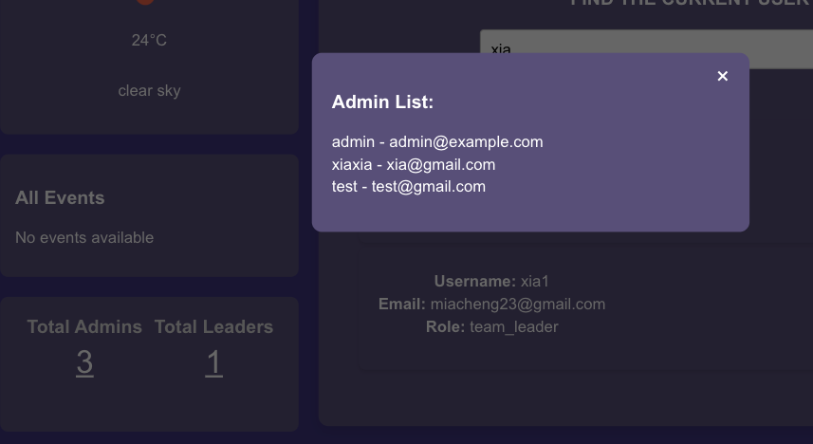

**3.4 Volunteer Points**

**3.5 Events**

**3.6 Reports**

**3.7 Change Password**

The Change Password page allows users to securely update their account password. To protect your account, it is recommended to change your password regularly and ensure the use of a strong password.

**3.7.1 Accessing the Change Password Page**

You can access the Change Password page by clicking on "Change Password" in the main navigation bar.

Steps to Change Your Password

1. Enter Current Password: Enter your account's existing password in the "Current Password" field.
2. Set New Password: Enter the new password you wish to set in the "New Password" field.
3. Confirm New Password: Re-enter your new password in the "Confirm New Password" field. Ensure that the new password entered matches the one above to avoid issues due to typing errors.
4. Submit Password Change: Once confirmed, click the "Change Password" button at the bottom of the page to submit the changes. If there is an error with your input or if it does not meet the password policy, the system will display an error message, and you will need to make the necessary adjustments according to the prompts.

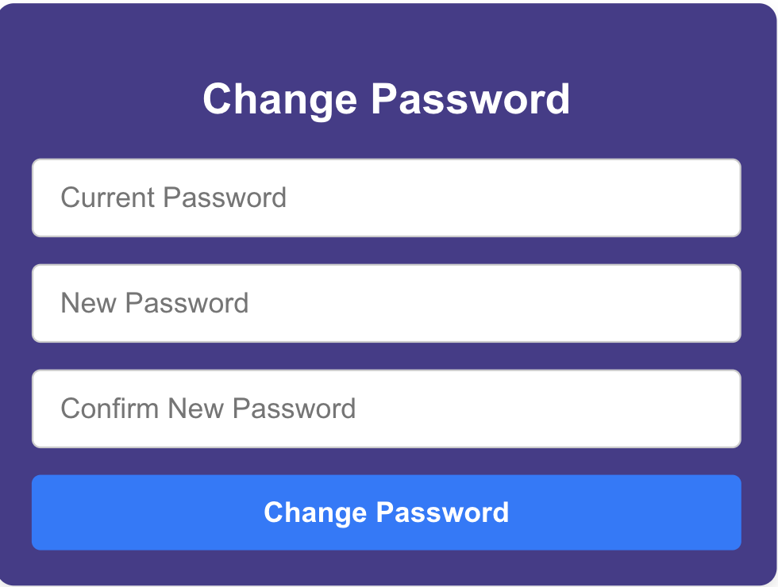

**3.8 Logout**

Click on "Logout" in the main navigation bar. You can log out to the current page.